Project Title

Arduino Password-Protected Door Lock System

1. Introduction
The purpose of this project is to design and implement a password-protected door lock system using Arduino. The system uses a keypad for password entry, an LCD to provide user feedback, a servo motor to control the door lock, a buzzer for alerts, and LEDs to indicate the status of the lock.

2. Components
The main components used in this project are:
- Arduino board
- 4x3 keypad
- LiquidCrystal_I2C LCD
- Servo motor
- Buzzer
- LEDs (Green and Red)
- Push button
- Resistors and Connecting wires

3. Circuit Diagram
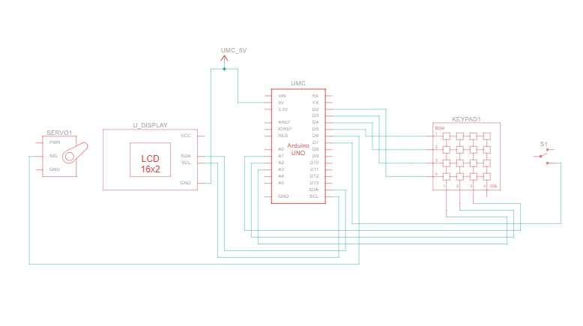

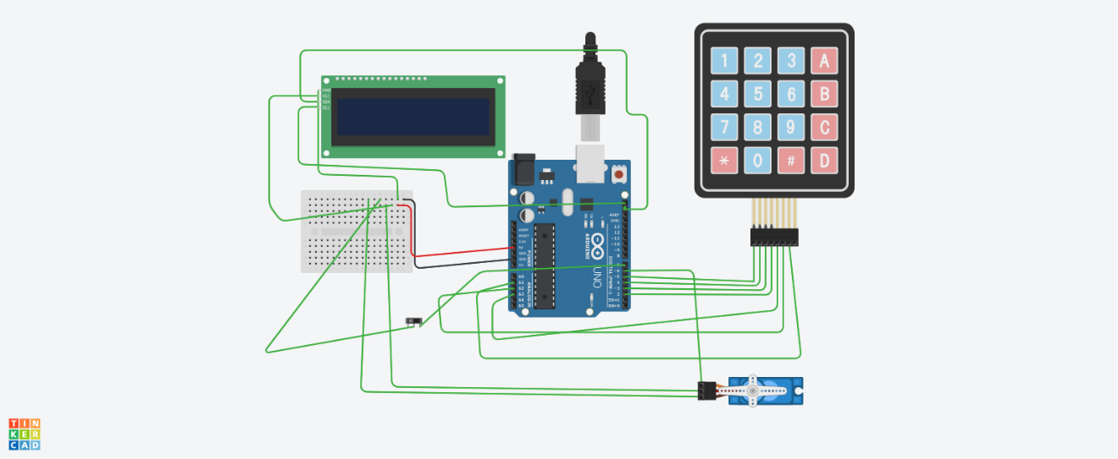

The circuit consists of connecting the keypad, LCD, servo motor, buzzer, LEDs, and push button to the Arduino board. The components are connected as follows:
- Keypad: Connected to digital pins 2, 3, 4, 5, and analog pins A1, A2, A3.
- LCD: Connected via I2C interface (SDA, SCL).
- Servo: Connected to digital pin 6.
- Buzzer: Connected to digital pin 8.
- Green LED: Connected to digital pin 9.
- Red LED: Connected to digital pin 10.
- Push button: Connected to digital pin 7 with internal pull-up resistor.

4. Software
The software for this project is written in C++ using the Arduino IDE. The code includes the following libraries:
- Keypad.h
- LiquidCrystal_I2C.h
- Servo.h
The main functionalities implemented in the code are:
- Reading input from the keypad.
- Displaying messages on the LCD.
- Controlling the servo motor based on password validation.
- Providing audio and visual feedback using the buzzer and LEDs.
- Managing the state of the door lock (locked/unlocked).
Code:
#include <Keypad.h>
#include <LiquidCrystal_I2C.h>
#include <Servo.h>

// Define the keypad
const byte ROWS = 4; // Four rows
const byte COLS = 3; // Three columns
char keys[ROWS][COLS] = {
{'1','2','3'},
{'4','5','6'},
{'7','8','9'},
{'*','0','#'}
};

byte rowPins[ROWS] = {5, 4, 3, 2}; // Connect to the row pinouts of the keypad
byte colPins[COLS] = {A3, A2, A1}; // Connect to the column pinouts of the keypad

Keypad keypad = Keypad(makeKeymap(keys), rowPins, colPins, ROWS, COLS);

// Define the LCD
LiquidCrystal_I2C lcd(0x27, 16, 2);

// Define the Servo
Servo servo;
int servoPin = 6;

// Define the Buzzer
int buzzerPin = 8;

// Define the LED pins
int greenLEDPin = 9;
int redLEDPin = 10;

// Define the Push Button
int buttonPin = 7;

// Define the password
String password = "1234";
String input = "";

// Variables to manage the door state
bool doorUnlocked = false;
unsigned long unlockTime = 0;
const unsigned long doorOpenDuration = 5000; // 5 seconds

void setup() {
Serial.begin(9600); // Initialize Serial Monitor for debugging

lcd.init();
lcd.backlight();
lcd.print("Enter Password:");

servo.attach(servoPin);
pinMode(buzzerPin, OUTPUT);
pinMode(greenLEDPin, OUTPUT);
pinMode(redLEDPin, OUTPUT);
pinMode(buttonPin, INPUT_PULLUP); // Internal pull-up resistor for the button

// Set initial state
servo.write(0); // Locked position
digitalWrite(greenLEDPin, LOW);
digitalWrite(redLEDPin, HIGH);
}

void loop() {
char key = keypad.getKey();
bool buttonPressed = digitalRead(buttonPin) == LOW;

// Check for button press to unlock door
if (buttonPressed && !doorUnlocked) {
unlockDoor();
}

// Check for keypad input
if (key && !doorUnlocked) {
Serial.print("Key pressed: ");
Serial.println(key); // Print the key pressed to the Serial Monitor

if (key == '#') {
if (input == password) {
unlockDoor();
} else {
lcd.clear();
lcd.print("Wrong Password");
tone(buzzerPin, 1000, 1000); // Beep the buzzer
digitalWrite(greenLEDPin, LOW);
digitalWrite(redLEDPin, HIGH);
delay(2000);
lcd.clear();
lcd.print("Enter Password:");
}
input = ""; // Reset the input
} else if (key != '*' && key != '#') {
input += key;
lcd.setCursor(input.length(), 1);
lcd.print('*');
Serial.print("Current input: ");
Serial.println(input); // Print the current input to the Serial Monitor
}
}

// Check if door needs to be locked after unlock duration
if (doorUnlocked && (millis() - unlockTime > doorOpenDuration)) {
lockDoor();
}
}

void unlockDoor() {
lcd.clear();
lcd.print("Access Granted");
servo.write(90); // Unlock position
digitalWrite(greenLEDPin, HIGH);
digitalWrite(redLEDPin, LOW);
doorUnlocked = true;
unlockTime = millis(); // Record the unlock time
}

void lockDoor() {
lcd.clear();
lcd.print("Enter Password:");
servo.write(0); // Lock position
digitalWrite(greenLEDPin, LOW);
digitalWrite(redLEDPin, HIGH);
doorUnlocked = false;
}

5. Implementation
The implementation involves setting up the hardware components and writing the code to handle the interaction between the user and the system. The following steps are involved:
- Setup: Initialize the LCD, keypad, servo, buzzer, and LEDs.
- Password Entry: Read the input from the keypad and compare it with the predefined password.
- Password Validation: If the entered password is correct, unlock the door and provide visual and audio feedback. If the password is incorrect, display an error message and sound the buzzer.
- Door Lock Management: Keep the door unlocked for a predefined duration and then automatically lock it.

6. Results
The password-protected door lock system was successfully implemented and tested. The system reliably locks and unlocks the door based on the entered password. The LCD provides clear user feedback, and the buzzer and LEDs effectively indicate the system status.

7. Conclusion
The project demonstrates the use of Arduino for creating a secure and interactive door lock system. The system can be further enhanced by adding features such as remote control, multiple user support, and integration with home automation systems.
...............................

